Introduction to educator competencies

The effectiveness of any educator development model will depend on the goals which the system wants to achieve through ICT integration. Since the enhancement of curriculum outcomes is the goal that the system wants to achieve through the integration of ICT, educator competencies in ICT integration should ultimately include facilitating, directly or indirectly, the way that learners learn, what they learn and how effectively they achieve learning outcomes.

It is widely recognised that ICT may play various roles in an education system. These are commonly translated in to professional development approaches which have the following 4 goals:

A. The acquisition of ICT skills in the contexts of the roles of the educator.
This means that ICT courses are offered with a specific focus on improving the ICT competence of educators, noting that this competence is learnt in contexts that are meaningful for the educator and not as ICT skills as an end themselves. Included in this type of training will be an awareness of the basic safety, information ethics and health issues related to the use of ICT.

B. Using ICTs to enhance learners’ abilities within the existing curriculum and/or educators’ professional abilities within their sphere of work.
This focuses on integrating ICTs into the daily work of all educators and learners. In some cases teachers’ existing pedagogical approaches and classroom behaviours remain the same, while in others and with time, ICT use tends to change the pedagogical approaches the teacher employs. Similarly, the efficiency of managers in producing and managing documents may improve, but their practice as managers may not always change noticeably.

There is a narrowing distinction between the skills development activities in approach A and approach B. It is considered effective practice to use the learners’ curriculum contexts and the educators work contexts as the basis for learning ICT skills from a very basic level. This replaces the traditional approach to “computer literacy” that has tended to focus on the erroneous assumption that one should learn ICT skills as an end to themselves prior to being able to implement these in meaningful contexts.

The e-Education White Paper refers to standards for professional competency in ICT use that should consider various levels. Approach A and B are aligned to the first two levels, namely:
- entry - computer literate, able to use computers and teach learners to use computers
- adoption - able to use various technologies, including the computer, to support traditional management, administration, teaching and learning

Developing learner ICT skills must be factored into the educator competencies. Learners must leave school as confident, creative and productive users of ICT.

C1. Introducing ICTs as an integral component of broader curricular reforms that are changing how learning occurs.

This focuses on how ICT can support the introduction of outcomes-based education principles in alignment with the revised national curriculum statements. Some focus is inevitably placed on pedagogical practice, notably the skills and abilities that are listed in Figure (Content framework diagram). Professional development outcomes at this level are meant to bring about change in classroom practice, notably regarding the role of the teacher (more facilitative) and learner (greater learner-centredness, more independent learning) and the role of information (produced rather than transferred – more emphasis on higher order thinking skills).

Educator development that is embedded in the curriculum and integrated with the assessment of learning is considered far more likely to lead to changes in teacher practice than teacher development programmes that are conducted as isolated exercises.

Whether the purpose is to improve literacy and numeracy, make challenging learning areas more accessible, or make learning more inclusive in recognition of the diversity of learners, this approach is one in which ICT is a ‘tool for learning’ rather than an object of learning. The focus of educator development is to help teachers use appropriate technologies in their classrooms across all learning areas. The assumption is that ICT is a useful pedagogical tool — a tool that can improve learning or change how learning occurs, but leaves the content — what is learned — relatively unchanged. Improved access to information and the use of communication technologies does, however, change the extent of content and learning experiences with which learners can engage.

C2. Introducing ICT as an integrated management tool that reforms the way in which management information is accessed and processed, thus reforming management practice.

This focuses on the use of educational management information systems (EMIS) and communication tools that make it possible for educators to enhance their professional knowledge and understanding through participation and support of a variety of education-related activities. Communication tools also make it possible for districts to support schools and for schools to communicate with their communities.

Professional development outcomes are transformative at the management level – they change management practice. They influence not only what information school leaders and district management have access to, but how they are able to manage ICT in education.

In terms of the levels of professional competency in ICT use, approaches C1 and C2 are aligned to the third and fourth levels, namely:

- adaptation - able to use technology to enrich the curriculum and to use integrated systems for management and administration
- appropriation - able to integrate technology into teaching and learning activities and to use integrated systems for management and administration within a community context

For education, educators and learners to benefit fully from the integration of ICT, they will have to reconsider themselves entirely - not only the structures of their learning programmes and their classroom techniques, but even their fundamental beliefs and attitudes concerning learning.

The US Department of Education recognised this when it linked the use of new technologies to school reform in the research project Technology and Education Reform (Office of Educational Research and Improvement, US Department of Education 1998). In its report it spoke about the role of ICTs in facilitating:
• learners learning through involvement with authentic, challenging multidisciplinary tasks;
• new roles for learners and educators;
• the professionalisation of educators;
• the creation of a culture that supports inter-related learning, both in the classroom/office and beyond the school/office walls.

D. Introducing ICTs as an integral component of the reforms that alter the organisation and structure of schooling itself.
This is transformative at the systemic level, leading eventually to changes in the organisational and structural features of schooling as well. This outcome would only be possible once effects of professional development and the consequent educational planning and management have permeated the system to a very large extent. Reform of this nature is often regarded with some trepidation, but the final outcome of all professional development should be that educators are open to recognising the changing technologies and their impacts, and are able to make informed decisions in their educational planning.
In terms of the levels of professional competency in ICT use, type D is aligned to the fifth level, namely:

- innovation - prepared to develop entirely new learning environments that use technology as a flexible tool, so that learning becomes collaborative and interactive. Technology is integrated as a flexible tool for whole-school development.

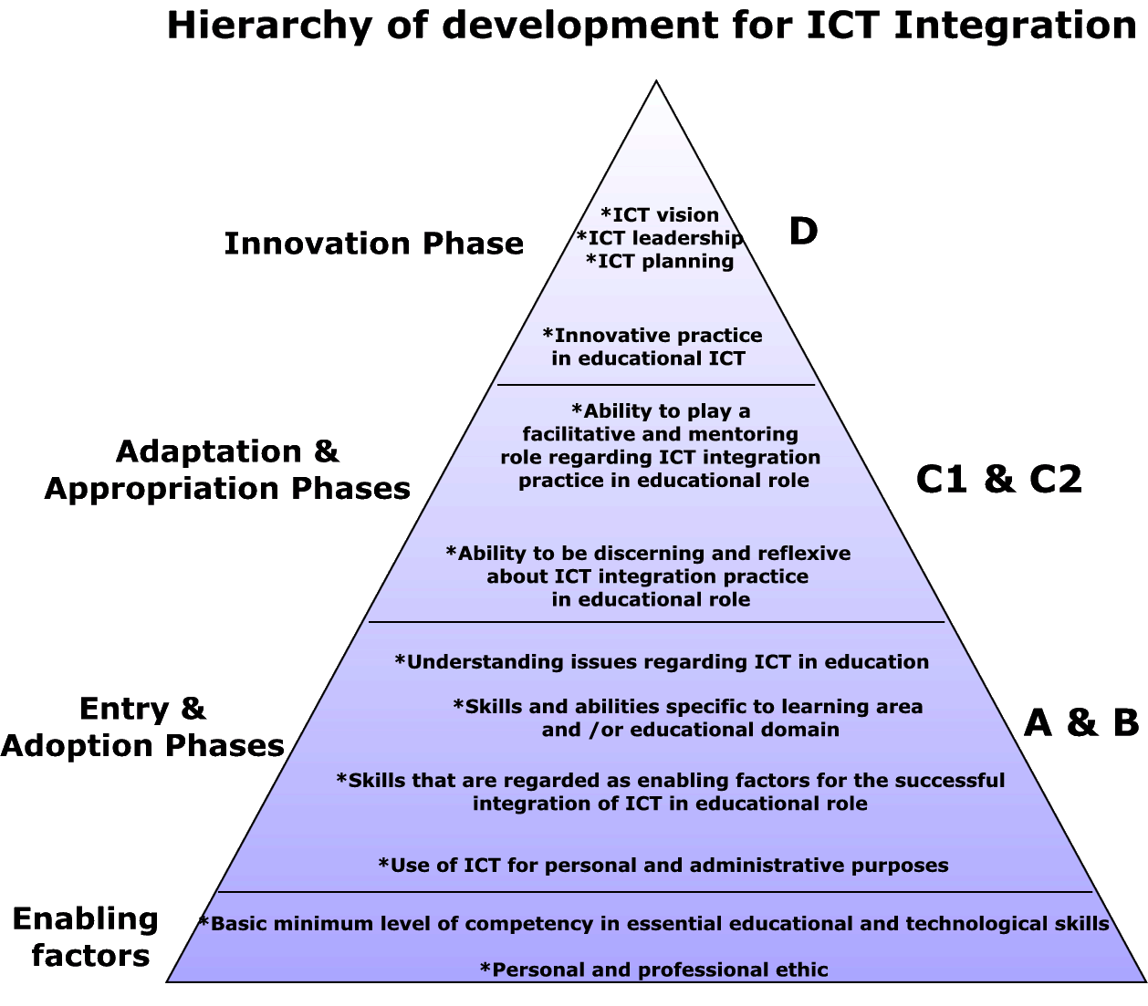

Educator competencies

Professional competence with ICT

- Draw on appropriate ICT applications to enhance personal and professional effectiveness
  - Fulfilling 7 roles of educator
  - Fulfilling school and district management roles
- Access and use electronic information and communications resources such as the Internet and e-mail, for the benefit of both the manager, educator and the learner
  - Participate and contribute to professional online communities
  - Facilitate collaborative learning between classes
- Reflect on practice with ICT in learning, then plan and implement appropriate and manageable change in practice
- Nurture the development of learner ICT competence in the context of educational use of ICT as a tool

Integration of ICT with Curriculum

- Be aware and model best practice in current health, legal and ethical issues regarding the use of ICT in the classroom.
- Apply outcomes based assessment strategies using the contribution ICT can bring to the process.
- Identify and use ICT resources that could most benefit teaching and learning in the learning area and phase
  - Evaluation of learning resources
  - Achieving learning outcomes
  - Apply teaching strategies where ICT supports teaching and learning.
- Organise the class and the classroom when making use of ICT to achieve learning outcomes.
- Display a knowledge and understanding of the characteristics of information and its role in learning
- Be aware of and plan for both diversity and uniqueness of learners through the use of ICT in learning
  - Inclusive education
  - Relevance to age range and phase
  - Diverse backgrounds

Management and leadership with ICT

- Apply knowledge and understanding of ICT integration when appropriate in fulfilling roles as an educator
- Provide a facilitative and mentoring role to other educators regarding the integration of ICT
- Participate in the development and evaluation of educational ICT policy at institutional/district level
- Embrace opportunities to make innovative use of ICT in one or more roles as an educator

Assessment of competencies

- Draw on appropriate ICT applications to enhance personal and professional effectiveness
We will know that the educators have achieved this competency when they:
  - confidently use a word processor for preparing basic documents associated with their roles as educators e.g. exam papers, reports and letters
  - confidently use a spreadsheet for processing documents that require number processing, e.g. mark sheets, budgets
  - use presentation software to support presentation of reports and talks to gatherings
  - use ICT to support administration, record-keeping, analysis and reporting
- Access and use electronic information and communications resources such as the Internet and e-mail, for the benefit of both the manager, educator and the learner
We will know that the educators have achieved this competency when they:
  - use e-mail to communicate with other educators on professional matters
  - participate and contribute to professional online communities
  - facilitate the use of e-mail by learners for educational use
  - use the Worldwide Web to find information that may inform and enhance their roles as educators
  - evaluate the credibility of web-based information

- Reflect on practice with ICT in learning, then plan and implement appropriate and manageable change in practice
We will know that the educators have achieved this competency when they:
  - express how they feel about a lesson involving ICT, or the effectiveness of any other use of ICT in their roles as educators
  - identify factors that should change as a result of reflecting on practice
  - identify strategies to change practice as a result of reflection
  - reflect and plan in such a way that it sound principles of practice in ICT integration can be implemented
- Nurture the development of learner ICT competence in the context of educational use of ICT as a tool

We will know that the educators have achieved this competency when they:
  - provide opportunities for learners to use ICT in the contexts of both curricular and extra-curricular activities
  - teach learners basic word processor and spreadsheet skills, e-mail skills and Web search techniques
  - provide support or arrange advanced support for learners working with ICT
  - are willing to facilitate learners who are working with ICT
  - use terminology which arises from the use of ICT in the learning area accurately and appropriately
  - model and give guidance to learners about the most appropriate ICT use for a specific purpose

- Be aware and model best practice in current health, legal and ethical issues regarding the use of ICT in the classroom.

We will know that the educators have achieved this competency when they:
  - model good ergonomics when using ICT
  - make learners aware of child safety on the Internet
  - implement measures to affect child safety on the Internet
  - take measures to avoid computer virus infection
  - take strict measures to avoid software piracy
  - ensure that learners are not able to plagiarise when working with information
  - ensure that they and learners implement “fair use” principles
  - insist on permissions and acknowledgements of the use of intellectual property of others as required
  - teach learners good “netiquette”
  - value the privacy of information
  - clearly define what information is inappropriate socially or morally

- Apply outcomes based assessment strategies using the contribution ICT can bring to the process.
We will know that the educators have achieved this competency when they:
  - assess developmental and critical outcomes that incorporate, directly or indirectly, the use of ICT as a tool
  - assess the specific contribution that ICT has made to learning
  - use ICT to produce assessment tools
  - use ICT-based assessment tools
  - assess the levels of attainment of individual learners when working collaboratively with ICT

- Identify and use ICT resources that could most benefit teaching and learning in the learning area and phase

We will know that the educators have achieved this competency when they:
  - explain why they have decided to use an ICT tool for a specific purpose on a specific occasion
  - explain how the use of ICT is beneficial to achieve learning outcomes
  - apply evaluation tools to digital learning resources
  - plan a unit of work deciding in advance when and how ICT will be used and assessed
  - emphasise the quality of content when learners use ICT productivity tools
  - know when and what inter-class collaboration is most beneficial
  - select tools and pedagogy that allow learners to manage their own learning
  - integrate ICT based and non-ICT base media into learning programmes
  - ask key questions that stimulate thinking

- Organise the class and the classroom when making use of ICT to achieve learning outcomes.

We will know that the educators have achieved this competency when they:
  - schedule ICT-integrated lessons in locations where ICT is available
  - manage learning environments that contribute to the use of different ICT tools and pedagogy
  - prepare equipment, content and pedagogy appropriately when ICT is to be used with learning
  - manage group work with ICT
  - manage large computer-learner ratios when working with ICT
  - manage variable learner competencies with ICT in learning situations
  - know what kind of intervention is most appropriate in the class in order to best facilitate learning
  - know when and what inter-class collaboration is most beneficial
  - select tools and pedagogy that allow learners to manage their own learning
  - manage technical breakdowns in such a way that on planned lesson outcomes is minimal

- Display a knowledge and understanding of the characteristics of information and its role in learning

We will know that the educators have achieved this competency when they:
  - prepare learners to find, compare, analyse and/or synthesise information from the Internet and other sources
  - phrase tasks in such a way that learners need to manage and present information using appropriate ICT tools
  - evaluate information in terms of its accuracy, validity, reliability and bias
  - choose and use appropriate tools to communicate with other sources of information
  - ask key questions that stimulate thinking
  - focus on information production by learners (with the support of ICT resources) rather than information transfer by teachers
  - manage information storage systems efficiently
  - make use of the dynamic nature of information, rather than just static information
  - link information between applications
  - share information with others

- Be aware of and plan for both diversity and uniqueness of learners through the use of ICT in learning

We will know that the educators have achieved this competency when they:
  - select and use ICT tools and pedagogy that is appropriate to the gender, age level and phase of learners
  - select and use ICT tools and pedagogy that is appropriate for learners with disabilities
  - design learning activities with ICT that cater for diversity of learners
  - vary the presentation, documentation and media supporting lessons
  - teach appropriate basic skills for handling input devices for Foundation Phase learners
  - use ICT to support the development of numeracy and literacy
  - use ICT to support the learners’ creative development

Management and leadership with ICT

- Apply knowledge and understanding of ICT integration when appropriate in fulfilling roles as an educator

We will know that the educators have achieved this competency when they:
  - participate actively in groups working about the use of ICT in education
  - use ICT tools to collaborate in the improvement of teaching and learning and management of the learning process
  - collaborate with management and administration regarding the implementation of ICT policy

- Provide a facilitative and mentoring role to other educators regarding the integration of ICT

We will know that the educators have achieved this competency when they:
  - propose learning pathways for learners and colleagues for development of ICT integration skills
  - sharing knowledge and experiences of ICT integration with other educators either in the school, district or nationally at conference or online
  - accompany and support colleagues in their individual learning with ICT or with their ICT integration in class
  - encourage independent learning with ICT by helping colleagues to solve problems themselves, and not solving problems for them

- Participate in the development, evaluation and implementation of educational ICT policy at institutional/district level

We will know that the educators have achieved this competency when they:
  - participate in ICT policy meetings, planning and implementation procedures of ICT policy
  - promote ICT integration within the school or district
  - take responsibility for the availability and usability of the ICT resources
  - mediate between the school/office and hardware and software providers
  - seek to improve their own ICT integration skills

- Embrace opportunities to make innovative use of ICT in one or more roles as an educator

We will know that the educators have achieved this competency when they:
  - experiment with innovative ideas gleaned from global sources on ICT in education
  - inform management of innovative use of ICT and publish the results of such experimentation widely
  - use ICT to model relationships, analyse data, make predictions

Appendix: Summary of educator competency mapping

Approach to professional development | Levels of technology adoption | Educator competency
The acquisition of ICT skills in the contexts of the roles of the educator;  Using ICTs to enhance learners’ abilities within the existing curriculum and/or educators’ professional abilities within their sphere of work. | entry - computer literate, able to use computers and teach learners to use computers  adoption - able to use various technologies, including the computer, to support traditional management, administration, teaching and learning | Professional competence with ICT  - Draw on appropriate ICT applications to enhance personal and professional effectiveness  - Access and use electronic information and communications resources such as the Internet and e-mail, for the benefit of both the manager, educator and the learner  - Reflect on practice with ICT in learning, then plan and implement appropriate and manageable change in practice  - Nurture the development of learner ICT competence in the context of educational use of ICT as a tool  Integration of ICT with Curriculum  - Be aware and model best practice in current health, legal and ethical issues regarding the use of ICT in the classroom.  - Apply outcomes based assessment strategies using the contribution ICT can bring to the process.

Introducing ICTs as an integral component of broader curricular reforms that are changing how learning occurs  Introducing ICT as an integrated management tool that reforms the way in which management information is accessed and processed, thus reforming management practice. | adaptation - able to use technology to enrich the curriculum and to use integrated systems for management and administration  appropriation - able to integrate technology into teaching and learning activities and to use integrated systems for management and administration within a community context | Integration of ICT with Curriculum  - Identify and use ICT resources that could most benefit teaching and learning in the learning area and phase  - Organise the class and the classroom when making use of ICT to achieve learning outcomes.  - Display a knowledge and understanding of the characteristics of information and its role in learning  - Be aware of and plan for both diversity and uniqueness of learners through the use of ICT in learning  Management and leadership with ICT  - Apply knowledge and understanding of ICT integration when appropriate in fulfilling roles as an educator  - Provide a facilitative and mentoring role to other educators regarding the integration of ICT
Introducing ICTs as an integral component of the reforms that alter the organisation and structure of schooling itself. | innovation - prepared to develop entirely new learning environments that use technology as a flexible tool, so that learning becomes collaborative and interactive. Technology is integrated as a flexible tool for whole-school development. | Management and leadership with ICT  - Participate in the development and evaluation of educational ICT policy at institutional/district level  - Embrace opportunities to make innovative use of ICT in one or more roles as an educator

