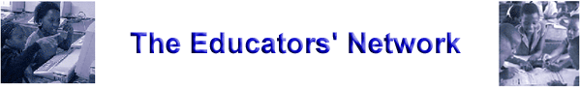

Activity 4C: Task 2 – Exploring security from different perspectives

Basic types of security systems

There are three main categories of security systems that are commonly used by schools to protect their ICT equipment. Most schools use a combination of these. Drag and drop the type of security system to its relevant security type.

Security Systems

