

YOUR NAME:

Activity 4 – Staff Development

Task 1

How will the role of the leader change with ICTs?

As an SMT member and leader in the school, bear in mind where educators are `at’. The introduction of computers into the school, will require that educators’ skills are enhanced accordingly. It is up to the leader to show the way. The role of the leader will change because:

Now Then
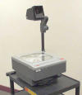

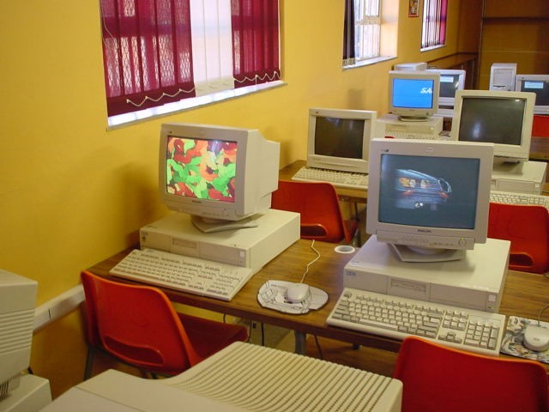

1. ICTs will cause certain resources to become obsolete. For example, use of overhead projectors and chalkboards may no longer be necessary, if educators have other tools such as interactive white boards and a classroom data projector linked to a laptop for lesson presentations.

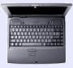

Then |  | Now
Multiple choice  Circle the correct answer  - When is the World Summit for Sustainable Development  - June  - August  - December |  | Online testing  Click on the right item.  - When is the World Summit for Sustainable Development?  - June  - August  - December

2. ICTs may make some assessment methods redundant. Low level knowledge for example, has been traditionally tested by the use of multiple choice questions. In an ICT environment, on-line testing provides the educator with a wide range of information associated with a learner’s score. Comparisons of previous scores and dates of assessment, for example, can indicate a child’s progress and each learner can be allocated an individual action plan in electronic format, based on a database of results.
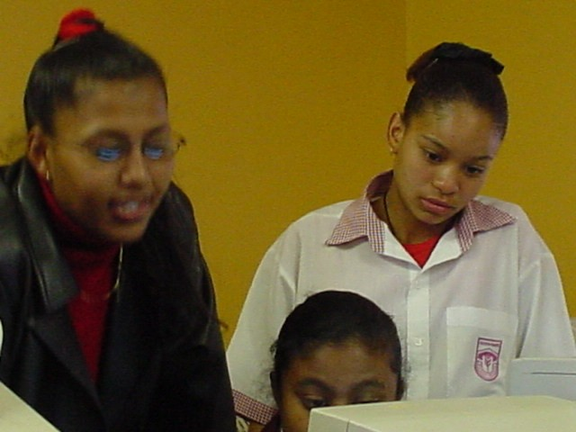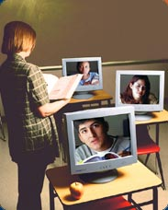

3. With ICTs, it is no longer sufficient for educators to merely impart content knowledge. They should encourage critical thinking skills. Using the Internet provides for inquiry-based learning, where educators and learners are able to access a variety of information sources. Educators and learners can connect with each other without being restricted to time or place.
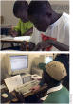




Traditional methods of imparting knowledge include lectures and books. However, human minds enjoy non-linear strategies for problem-solving and the storage and retrieval of information.

