

YOUR NAME:

Activity 4C: Task 1 – My current school situation

Questionnaire on your schools ICT infrastructure and security systems

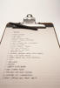
This questionnaire enables you to assess your school security system. Answer all questions. Click on the answer appropriate to your school situation. Your answer will be automatically scored. If you want to keep your work, after you’ve completed the questionnaire, print it out.

- What is the level of crime in your area?
  - Very high.
  - High.
  - Average.
  - Little crime.
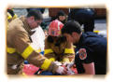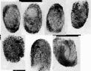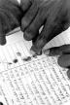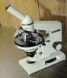
- Is there a police station nearby?
  - Yes.
  - No.

- What is the distance to the nearest police station from your school (in Km’s)?
  - Less than 1 km.
  - 2-5 km’s.
  - 5-10 km’s.
  - 10 km’s + .

4.i ) Do you have a police patrol in your area that frequently passes by the school?
- Yes.
- No.

4. ii) If yes, how often do they patrol your area?
(a) Everyday.
(b)Once a week.
(c)Once a month.

- Has your school ever been vandalized/burgled?
(a)Yes.
(b)No.

- If yes, how long ago was this last burglary / act of vandalism?
(a)Within the month.
(b)More than a month ago.
(c)Last year.
(d)More than 2 years ago.

- Is your school in isolation or is it within a community/township?
(a)Isolation.
(b)Within a community/township.

8. i) Does your school have a fence?
- Yes.
- No.

(ii) If yes, describe the type of fence.
- High walled.
- Locked gate.
- Barbed wire fence.

9. What type of surveillance system is present at your school?
For example:
- Video camera, electronic doors, alarm system, high fence.
- Fence and security guard.
- None.

10. Describe the type of security weapons that your security company/guard uses.
- Fire arms, watch dog, walkie talkie.
- Baton.
- Nothing.

11.How are the computers stored?
- In the office.
- In a special safe.
- In the computer lab with a strong security system.
- No specified area.

12.Who authorizes how the computers are used?
- Nobody, it’s open to all.
- The principal and SMT members.
- A chosen ICT committee.

13. Describe the room where the computers are stored. Which sentence most closely approximates the situation at your school? Choose one.
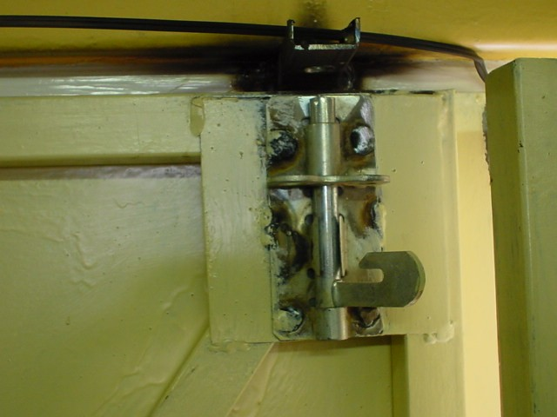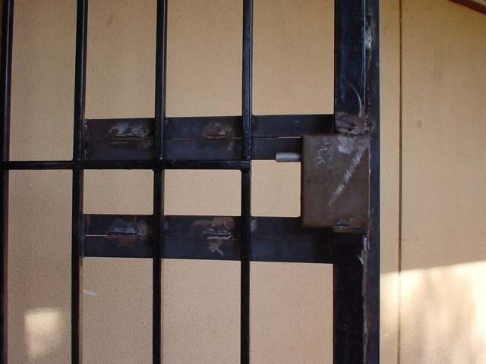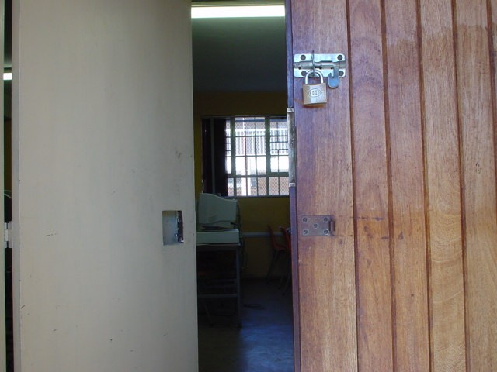

  - They are stored in a room with locks and doors, windows are safely secured, there is a burglar system and the ceilings are reinforced.

(b) They are stored in the office, where there is no special burglar system, but a night guard is on watch for the whole school.

(c) They are stored in the computer lab which has a double door, but no alarm system.
(d) They are stored in the room where they are used most, however, there is no infrastructural security in place here.

14. Who keeps the keys to the room where ICTs are stored?
- The Principal and/or SMT members keep the keys.
- They are kept in the staff room, for all to access.
- They are kept by an ICT team member.
- No specified person is charged with the keys.

The Scoring Framework

Check how you scored for each item. See the grading system given below which comments on the nature of the security system at your school. The total is done automatically.

The Scoring
1 | (a) | 10
 | (b) | 7
 | (c) | 6
 | (d) | 3
2 | (a) | 2
 | (b) | 8
3 | (a) | 1
 | (b) | 4
 | (c) | 7
 | (d) | 10
4 i) | (a) | 2
 | (b) | 8
4 ii) | (a) | 1
 | (b) | 4
 | (c) | 7
5 | (a) | 8
 | (b) | 1
6 | (a) | 10
 | (b) | 8
 | (c) | 6
 | (d) | 3
7 | (a) | 10
 | (b) | 7
8 i) | (a) | 1
 | (b) | 8
8 ii) | (a) | 2
 | (b) | 4
 | (c) | 5
9 | (a) | 2
 | (b) | 6
 | (c) | 10
10 | (a) | 2
 | (b) | 5
 | (c) | 8
11 | (a) | 4
 | (b) | 2
 | (c) | 1
 | (d) | 8
12 | (a) | 8
 | (b) | 4
 | (c) | 2
13 | (a) | 1
 | (b) | 6
 | (c) | 7
 | (d) | 9
14 | (a) | 4
 | (b) | 9
 | (c) | 2
 | (d) | 10

Check your scores

0 – 33 Your security system is quite good. You just need to strengthen the already existing system.

34 –79 Room for improvement.

80– 99 You might be nursing a time bomb, as you are a relatively easy target for a burglary. Strengthen the security at your school.

100 to137 There are serious problems with your security system. You need good planning.
…………………………….

