

Activity 4C: Task 2 – Exploring security from different perspectives

Key Infrastructure and Security Issues

Introducing computer facilities into a school requires a great deal of preparatory work. The degree of thought that goes into the preparation will dictate the survival of the equipment and the future of learning areas that are dependent on the equipment e.g. Computer Studies.

Explore the information presented in each of these sections:

  - The safety and security of equipment

  - Position, access and use patterns in an ICT room

  - Environment (lighting, electricity etc.)

  - Proper furniture for ICT usage

  - Proper locations for ICTs

  - More information on proper electrical usage

  - Mistakes to avoid

The Safety and security of equipment

- The theft of equipment in schools is an ongoing reality and threat for schools. A school must therefore ensure that it has adequate security before it proceeds to purchase equipment. Although rugged burglar proofing and alarm systems are not entirely adequate solutions to the problem of theft, they do act as a deterrent.

- Equipment is fragile and can be easily damaged, if handled incorrectly. This necessitates supervision by educators.
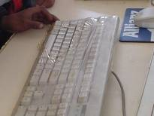
- The implications regarding the use of equipment after school hours must be considered.
- Schools that have access to the Internet should enforce rules about appropriate and educationally accountable Internet use. Abuse of the facility at an institution’s expense, e.g. in visiting pornographic sites, must be avoided.
- The use of passwords or, if necessary, stronger measures, must be enforced to protect confidential data at a school e.g. examination papers, etc.

Back to top

Position, access and use patterns in an ICT room

- In the current SA education system, a standard classroom can be converted into a computer laboratory. This decision does depend on the financial situation of the school concerned.
- The decision regarding access, use patterns and the control of the computer room will depend on teaching and learning methodologies and will be unique to each particular school.
- The needs of learners must dictate decisions taken and not be determined by the distribution of computers in a school.
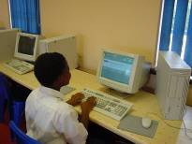
Back to top

Environment (ergonomics, lighting, electricity etc.)
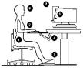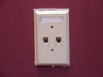
It is important that careful planning goes into the establishment of an ICT room. Ensure that the following aspects are considered:

- Provide space for telecommunications or equipment closets – Cables connect file servers, routers, amplifiers and so forth to the end-user equipment, which can be in virtually every room of the school building. The file servers, routers and amplifiers require space, electrical power and climate control. Over the years, many of these connections will need to be changed because of new equipment, new user stations, new software and for other reasons. Therefore, the closets built for this purpose need to be large enough to accommodate not only the existing equipment, but provide sufficient room for the people who make and remake the connections to work.
- Experienced planners suggest at least one telecommunications closet with a minimum of 4 square metres of space for a building with a total of 600 or less square meters. Telecommunication closets must have proper ventilation, air filtration, heating, cooling, humidification and electrical power, as well as plywood wall panels to permit mounting equipment racks. In multi-story buildings, the telecommunication closets should be located directly above one another to eliminate unnecessary horizontal wiring.
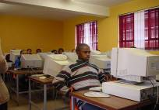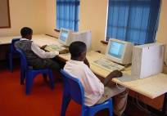

Back to top
Proper furniture for ICT usage

- Ergonomically incorrect furniture will result in body stress when equipment is used for long periods.
- Careful consideration should be given to acquiring computer furniture that is comfortable, durable and allows for maximum usage of the space where the computers are used.
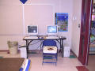

Back to top

Proper location for ICTs

- Adequate space should be made available between the computers in a computer room for learners to write into their notebooks during a lesson. It is a reality that there are presently insufficient classrooms in schools. Therefore, a request to use a classroom specifically for the purpose of computer lessons might not always receive favorable consideration.
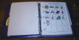
- The positioning of printers in a room is very important. Printers must be accessible to all learners in a class and not create congestion at any one point, especially during practical exams.
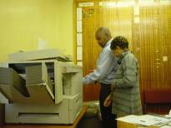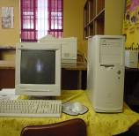
Back to top

More on proper electrical usage

- Plan for plenty of electrical outlets (or junction boxes) and circuits. Electric power points in each classroom should include at least one quadplex outlet in the center of the teaching wall, at least one duplex outlet on each wall where there are additional outlets. These should be no more than 3 metres apart, and at least four 15-amp circuits providing electrical power. The power should be “clean,” i.e. allowing no spikes or drops, and causing no interference to electronic devices.
- Diffuse the natural light from skylights and windows. While natural light is beneficial in many ways, it is subject to swings in intensity and direction and will cause reflections on computer screens and projection surfaces. Shades might eliminate this. Some schools have installed screens to diffuse the light from skylights. Ideally, all lighting, throughout the facility, should be direct or recessed, so that glare on computer or video screens is not a problem.
- Ensure that the bank of ceiling lights parallel to the projection screen wall, if there is one, can be switched off. Room lights can wash out dim projection images such as those from computer projection panels used with an overhead.
- Provide an environment free of static electricity and dust - humidification control, appropriate floor covering and alternatives to the chalkboard are essential, wherever computers are used. Hard surfaced, non-conducive flooring or special anti-static carpets woven with conducive fibres are recommended for use in the computer and communications room(s). These floor coverings should have anti-static chair mats that can be grounded in front of the equipment used.
- Make sure that all spaces are as adaptable as possible to changing needs - an open concept design offers optimum flexibility, but does not separate noisy activities from quiet activities. The concept also requires floor to ceiling cabling to provide electrical access. Movable dividers and demountable walls offer a way to separate activities, but do not solve the cabling problems.
- Be sure that the library media center and the communication hub are centrally placed. Careful discussion of what resources need to be accessed by users will bring to light those functions or areas that should be most centrally located.
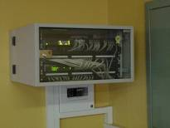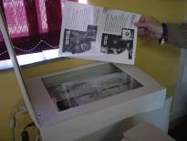
Back to top
Mistakes to avoid

  - Inadequate planning for future wiring and cabling needs, as the computer building/room is being designed.
  - Skimping on the number and size of wiring closets.
  - Trying to get by without sufficient technical staff, such as a network administrator or a systems operator.

  - Excluding the library media programme from the planning process. Surprising as it may seem, the school’s major source of information is overlooked. The library media programme can be a leading force in adapting technology to education. To gain maximum benefit from this source, library and media staff need to be involved in the planning process from the beginning.
  - Not providing surge protectors and uninterruptible power supply (UPS) units.
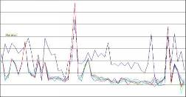
  - Not providing a detailed map of the network. Even if the person who figured out how to connect all the parts of the system never has a sick day or never retires, human memory is subject to occasional lapses, and tracing the cause of a classroom software problem will be much less frustrating and costly, if a carefully drawn and annotated map shows where each wire begins and ends.

