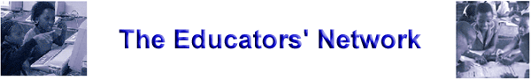

YOUR NAME:

Activity 3C – An ICT specific SWOT analysis of our school

Strengths:   | Weaknesses:  
Opportunities:   | Threats:  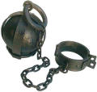

Key ICT related themes that recur at our school:

About our school’s alignment between the general vision and its ICT-specific vision:

