

Activity 4C Task 4 - Planning or improving my school’s security systems

Matthew Goniwe High School: ICT Security Policy

1. Local Area Network Security Issues

The user must act reasonably. Loading non-approved software could cause major problems. Good password practice is required including log-out after use.
  - The workstation should be secure from casual mistakes by the user.
  - Cabling should be secure and wireless LAN safe from interception.
  - Servers must be located securely and physical access restricted.
  - The server operating system must be secured to a high level.
  - Virus protection for the whole network must be installed and current.
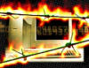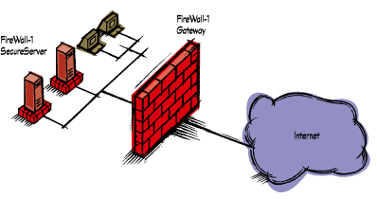
2. Wide Area Network (WAN) Security issues

- All external connections must be assessed for security risk including the wide area network (WAN) connection and any modems staff may wish to use.
- Decisions made on security by external agencies must be discussed with the school. Third party security testing should be considered.
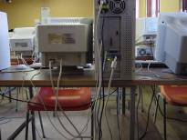
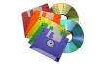

3. Authorized & Unauthorized Access

Procedures for gaining permission to use a computer system should be clear.
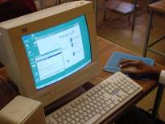
Permission to access a computer system in the school is normally given through the issue of a computer identifier (and an associated password). Such identifiers and passwords are issued to named individuals only and must not be shared with others.
Attempts to obtain and/or use computer identifiers and passwords of other users is deemed to be unauthorized access and will be dealt with severely.
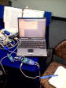

If you access computers outside of the school, you must observe school rules as they apply to you. Only make use of external computer systems that you have permission to use, which, in the world of the Internet, can be sometimes difficult to determine. Simplistically, permission to use a system is often granted, if you have been given a valid computer identifier and password to the owner of that computer system (either personally, or through some automated login process).

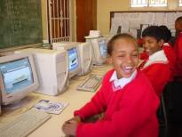

4. Downloading Files

On computers administered by the school, learners may assume that they have been authorized to read files that they can access. Note, however, that this is not an invitation to search for files where `read-only’ access can be obtained. This authorization does not apply to files accessed by any subversion of the file protection system.

Care should be taken in downloading files from other computer systems to which you have access, particularly on the internet. Just because information is accessible on the internet does not mean that you have permission to copy it. Issues dealing with copyright needs to be established before files are copied.
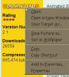

5. Unloading files

General permission to write on the file owned by somebody in the school is not granted regardless of the permission set in the file system. Write only to your own files, unless permission has been specifically granted to you.

Under no circumstances may members introduce software onto the school system unless they have permission from the school ICT media or equipments committee. Members wishing to upload onto the school system should seek permission from their ICT co-ordinator.

6. Physical Security

- Burglar doors.
- Watch dog situated near the computer lab.
- Security guard – 24 hour service.
- Daily supervision by staff members on duty.
- High walled fences.
- Community policing.

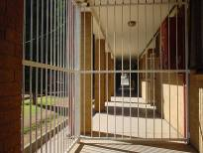

7. General

The school ICT system will be reviewed regularly with regard to security.

Virus protection will be installed and updated regularly.
Security strategies must discussed with the District, particularly where a wide area network (WAN) connection is being planned.

Personal data sent over the Internet will be encrypted or otherwise secured.

Use of floppy disks will be reviewed. Personal floppy disks may not be brought into school without specific permission and a virus check.

Unapproved system utilities and executable files will not be allowed in learners’ work areas or attached to e-mails.

