ICT PLANNING FOR SCHOOLS

Activity 1A - In which “phase of ICT use” is your school?

Four phases of ICT use:
1. Emerging
- Applying
- Integrating
- Transforming

Emerging

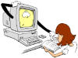
This approach describes a school in the beginning stages of ICT development. The school begins to purchase or has had some equipment and software donated. In this initial phase, administrators and educators are just starting to explore the possibilities and consequences of using ICTs for school management and the curriculum. The school is still firmly grounded in traditional, educator-centered practice. For example, educators lecture and provide content while students listen, take notes, and are assessed on prescribed content. Learners’ access to technology is through individual educators. “Leading light” teachers may be running some computer literacy lessons or courses, focusing on learning about ICT e.g. word processor courses. The expansion and refinement of such a programme could lead to development towards the next phase.

It is possible that the school may be offering computer studies as a subject, but this is not necessarily a sign of whole school development with ICT. These computers are often not accessible to the staff and learners in general.

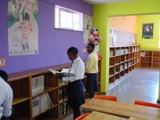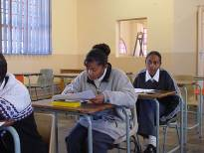

Applying

This approach describes the school in which new understandings of the contributions of ICTs to learning have developed. In this phase, administrators and educators use ICTs for tasks already carried out in school management and in the curriculum. Educators largely dominate the learning environment. For example, educators’ lectures may be supplemented with ICT use, such as presentation programs and word-processed handouts. Learners listen to lectures and add notes to educators prepared handouts. They use ICT tools in limited ways to complete required lessons. Learners’ access to technology is through one or two classroom computers and computer labs. It is possible that learners are attending scheduled computer literacy classes, involving more than one teacher. In these classes the emphasis is on educators teaching about the computer and not learners learning with the computer. Up until now, ICTs have been taught as a separate subject/learning area. To move to the next phase, the school chooses to integrate ICT, which increases the use of ICTs in various learning/subject areas with specific tools and software. The introduction of ICT alone will not give rise to a change in teaching and learning methods and effectiveness; a staff development programme needs to be underway by this stage. This programme should be focusing on how educators can integrate the use of ICT in curriculum-related activities.

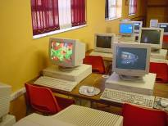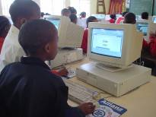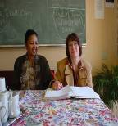

Integrating

This approach describes a school that now has a range of technologies both in laboratories, classrooms and administrative offices. The school staff explores new ways in which ICTs change their personal productivity and professional practice. The curriculum begins to merge subject areas to reflect real-world applications. For example, content is provided through multiple sources including community and global resources through the Internet. Learners’ access to technology enables them to choose projects and ICT tools to learn and demonstrate their knowledge across learning/subject areas. School organisation provides overlap and flexibility to combine subjects and time periods. Learners have more choices with regard to learning styles and pathways. Staff development and support in the integration of ICT continues throughout this stage.

They take more responsibility for their own learning and assessment. To advance to the next phase, the school chooses an ICT-curriculum that allows a project-based, ICT-enhanced approach. Schools begin to involve the community in the learning environment, both as users and as resource providers.

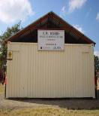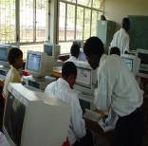
“It’s never too late to learn.
If schools in your area have a community outreach, you too can benefit from programmes which offer access to using ICTs”.

Transforming

This approach is linked with a school that has used ICTs creatively to rethink and renew school organisation. ICTs become an integral though invisible part of the daily personal productivity and professional practice. The focus of the curriculum is now learner-centered and integrates subject/learning areas in real-world applications. For example, students may work with the community with ICT tools. Learners’ access to technology is broad and unrestricted. This has only become possible because the educators have undergone training and support in ICT integration and they have planned and implemented new approaches to teaching and learning that include the use of ICT as a supporting tool. They take more responsibility for their own learning and assessment. The school has become a center of learning for the community.

