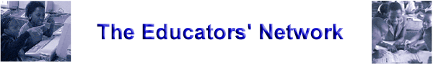

Activity 2B – Evaluating ICT policies

Focus on ICT policies

We are now moving from general information on policies, to specific information about ICT policies. In this task you will gather ideas about various ICT-specific questions that an ICT policy needs to address. Read the information provided.

When drawing up ICT policies, there are some principles that need to be followed in order to achieve the most effective result.

When you develop your own policy you need to answer several questions:
- Why should a school have an ICT policy?
- Who should be involved in putting the ICT policy together?
- What should the ICT policy include?

Read the additional information included on some of your possible responses to these questions.

Why should a school have an ICT policy?

More and more schools and educators are becoming convinced of the potential of Information and Communication Technologies for teaching and learning. However, schools should determine their plans for the inclusion of ICTs in the curriculum, as best suits their particular situation. Schools differ in size, layout and the technical expertise of the staff, so there is no one solution that schools can follow to ensure that maximum benefit from the use of computers can be derived. Schools have now become targets for the marketing of the latest hardware and software. It is important, therefore, that schools should decide how they wish to utilise the emerging technologies to best meet their needs.

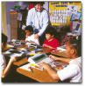

Who should be involved in putting the ICT policy together?

The entire staff, as well as, parents and management, should be involved in the creation of the school ICT policy. Some schools have found it useful as a starting point to use a questionnaire or to have a brainstorming session where educators are allowed to state what they feel the plan should include. An educator or principal can draw up a first draft of the policy. The policy is then circulated amongst all the stakeholders for comment or correction. The policy will evolve and require regular review and updating.

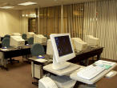

What should the ICT policy include?

The ICT policy should include some or all of the following components, as deemed necessary by the school:

Click on the heading to read additional information for each section.

Other Aspects

Teaching & Learning
Hardware / Software

repairs
Financial Plan Budget

Staff Development Planning

Control and Monitoring

How can ICTs enhance teaching and learning?

Schools need to decide if / why ICTs are required in their particular school and to identify how they can impact on learners and educators. The potential as well as the limitations of the technology needs to be discussed and a consensus needs to be reached on the justification of spending scarce resources on hardware, software and peripherals.

Within the context of the overall school curricular plan, the computer could be looked at as a tool for motivating learners and allowing opportunities for collaborative and social learning. Many curriculum reinforcement packages allow for very specific individualized learning and the use of ICTs in remedial teaching or with learners of exceptional ability. This can be investigated. ICTs allow learners access to huge amounts of information through reference packages and the Internet and, in this context, the role of the educator as a “ facilitator of learning” can be addressed. Adaptive technologies open up immense possibilities for learners with special needs and many schools may need to look at this area in their school plan.
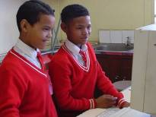

Back to top Back to diagram

Financial plan budget

The financial plan and the budget for the purchase of hardware, software and maintenance over a defined period of time (for example: 3 years in the medium term) should be documented. As existing hardware depreciates and edges towards obsolescence, it is worthwhile to consider whether the purchase of new or replacement hardware should be included in the budget. Many schools fall into the trap of over–allocating funds for hardware. The computer is only as good as the software it is running and the peripherals it operates.

Back to diagram

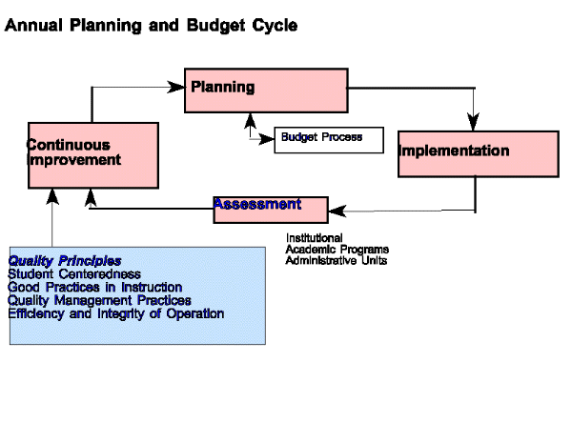
Back to top
Staff decision on hardware allocation

The staff may have to decide if they wish to have the hardware located at a central location (computer room) or as spontaneous learning tools within classrooms themselves, or a combination of both approaches. Often, computers are stored on trolleys for ease of movement to classrooms. It will then have to be decided how often each class gets computer access and for what duration.



Back to top Back to diagram

Hardware upgrades

- How often?
- By whom?
- What budget is located for it

Software
Evaluation of new soft ware

- How often?
- Who evaluates?
- What criteria?

Back up of software and data and storage of all media and manuals
- Who does the back–up?
- How often is back–up needed?
- What type of back–up is best suited to the school needs?
- Where are back-ups stored?
- Who has access?

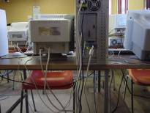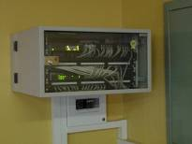

Back to top

Staff taking home computers during holiday time for familiarisation purposes (this needs proper control and monitoring)

Most educators do not have the time to learn how to use computers during their busy school day. Some schools opt to allow educators to take home a computer during the evenings, weekends or holidays so that they can learn and experiment at their own pace. Desktop computers are not very amenable to constant re–assembly. Therefore, it must be decided whether the longevity of the computer or the expertise of the staff receives greater weight. If financial resources permit, the purchase of a portable laptop may be a consideration.


Back to top Back to diagram

Responsibility for repairs

A proper plan should be put in place regarding computer repairs. This is because computer down time may take time to be sorted out.

Only properly trained computer technicians should be allowed to repair the computer.

It is therefore very important to budget for computer repairs in the initial budget.

Back to diagram



Staff development

The importance of staff development cannot be underestimated. Although there may be existing expertise in the school, plans should be put in place to ensure that this expertise is shared and updated, that all educators are given a scheduled opportunity to learn and that training is a regular and ongoing process. The plan should state the budget for staff development procedures and should also state whether the staff development will involve the whole school, be in-house, classroom-based, or take place during or after school hours, such as during holiday time.

Back to top Back to diagram

Other aspects which may be included in a school policy

Who is responsible for ICTS at the School

- The class teacher?
- The principal
- Who else?

What other aspects should be included? Note down some pointers in your portfolio. Have all the categories covered the scenarios presented in activity2a?

Back to diagram

