ICT PLANNING FOR SCHOOLS

Activity 4B: Task 2 – Exploring different views of educators on using ICTs

Comment from Educator 1:

Educators have some anxiety about the ability to use ICTs freely:

“My knowledge is limited on how to set up these programmes.”



How can you support this educator?

Comment from Educator 2:
Another educator described how he successfully used computers in
health education. “We used it successfully in our health education period.
Learners enjoyed going into the topic of the human body. It is more interesting than looking at books. With the software that we have, you can see how blood circulates. We had a good discussion on that.”


How can you use this knowledge in developing your own staff members? .

Comment from Educator 3:
“I see the computer being used as a source of information more in the upper primary and secondary school. The lower and the middle rely on prepared materials”.

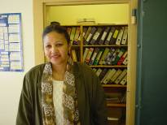

Do you think this is true? Explain your answer>

Comment from Educator 4:
ICTs are also seen as a motivator to learning in secondary schools.

An educator of African languages says the following:
“Kids love machines and, if we had the multimedia angle, it would be something that would provide incentive to motivate learners of all levels, not just those who feel that they can achieve and go beyond Standard Grade.”

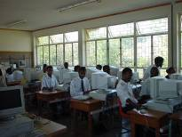
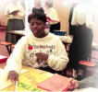

What is your view on this? Explain.

Comment from Educator 5:
Educators recognise the value of the internet as an information source.



“The internet can be helpful in history class, where sometimes we are trying to find out obscure points. I’ve got a boy, at the moment, who’s looking for local history. If he were able to use the internet he would be able to find a lot of information”.
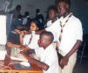

Look at your school. Is this possible? Explain.

Comment from Educator 6:

However not all educators see the internet as a valuable resource:

“The internet is a gimmick. It only tells you where information is: I’ve used it for three years. A lot of it is a waste of time”.
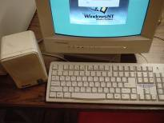

Do you have such educators at your school? What can you do to change this belief?

Comment from Educator 7:
The use of e-mail among educators varies. Some educators recognise the potential for broader collaboration and sharing of ideas that e-mail offers. However, they often find it difficult to persuade others of these benefits.

“It would be nice even to find a linked school in another country and then you could send them a daily bulletin of your school, and they could send you theirs. That sort of thing: real contact, makes language study more real – E-mail pals, instead of pen-pals.”

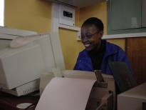

Do you think you can encourage your educators to collaborate more broadly with other schools? Explain your answer.

Comment from Educator 8:
ICTs across the curriculum: There are different views on how ICTs can be integrated into the curriculum.

Some feel that it is better to ensure that educators have certain basic skills and that their knowledge is developed and tested first. As one primary educator commented.

“Obviously it is the way forward and I’m of the old school, because I still believe that I would rather spend the time teaching how to use a dictionary and encyclopaedia and reading skills, rather than ICT skills such as searching for information on the web. If learners master traditional reading skills they can always reach higher.”

How would you respond to this educator?
