ICT PLANNING FOR SCHOOLS

Activity 3B – SWOT analysis of a case study

Case study on Nkazimlo Primary School

The Nkazimlo Primary School is a primary school situated in a rural village about 20 kilometres from the nearest town.
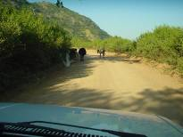

The school has 810 learners from Grade 1 to Grade 6, 18 classrooms and a staff room which is also used by the Principal and school administrator. Most of the learners come from poor homes and are often required to assist grandparents to look after younger siblings or relatives, as well as do household chores, such as finding wood and fetching water. The majority of parents are migrant workers. The school has 19 educators, including the Principal. The school was lucky enough to get a donation of 3 computers from a large private sector organisation, as well as a once-off amount of R10 000 for upgrading security. The computers are in the staff-room/principal and administrator’s office. Recently, the school conducted an audit. The school focussed on collecting information around ICTs, Staff Development, and the physical resources at the school. These areas were chosen because the SMT and the SGB agreed that they did not know enough about them, and that these areas were important in terms of informing decisions that the school would take around what it wanted to do and achieve.



What emerged from the audit was the following:

- The school has a Vision and Mission Statement developed jointly by the SGB and the SMT. The vision of the province and the vision of the school in their statements about quality education are very similar. However, the School’s Vision was developed before ICTs were introduced, so there is no reference to ICTs anywhere in its Vision.

- Staff are very positive about the leadership at the school and are willing to take on new duties and to learn new things, such as develop ICT skills to bring about change at the school.
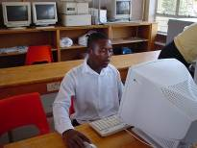
- The Principal is highly respected in the school and has the support of all the educators and of the families of learners. He is a skilled educator and communicator who was involved in the provincial discussions on Curriculum 2005. He leads by example and the SMT does the same. He is very positive about ICTs, but does not use them himself.

- Some of the educators at the school have experience in teaching adult basic education and remedial classes. One educator has completed a course in MS Word, and the school administrative officer is able to operate basic packages, though she gets stuck when a technical problem arises. Other educators at the school said that they were scared to use ICTs.

- The educators follow an agreed upon Code of Conduct and see themselves as professionals who act in a professional way.

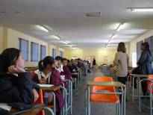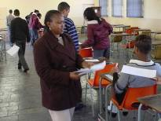

- Learners are treated with respect and every effort is made to meet the needs of those who are struggling with remedial difficulties. While all educators at the school are committed to meeting individual learners’ needs, they do not always know how to help children with learning problems. This is because some educators at the school have no training and/or experience in successfully handling children who have special needs.

- The school is well-organised. Time-tables are completed before the school opens each new year. The distribution of work among staff is fair, though a recent redeployment of some educators has affected morale at the school. There is no slot on the timetable for regular staff meetings or time set aside for staff development during school hours.

- Some of the more skilled educators feel that their skills are under-utilised and that they are not sufficiently challenged. There is very little formal staff development and some of the less skilled staff feel unsure about what is expected of them or whether the school management is open to them taking on more initiative.


- The teaching methodology at the school can be characterised as being mostly “chalk and talk” (i.e., instructional activities are educator rather than learner-centred). Very few computer generated worksheets are used, and learners’ marks are recorded in writing. School reports cards are still generated by hand. This is a cause of frustration for educators at the school, as the writing of reports tends to be a very time-consuming process. For the first time this year, however, class lists were captured using school computers.


- There are no extra facilities for the learners such as a library or extra-mural activities. There is no access to ICTs for learners, although some Grade 6 learners have asked for access.
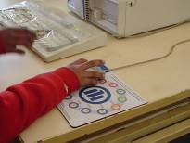

- The buildings are solid, but shabby looking. There is no fence and the only security at the school is provided by the burglar bars on the windows of the staff room. Seven sets of keys have been issued in the past, but no-one knows who has one of these sets.
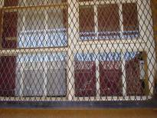
- There is quite a lot of crime in the area because of high unemployment.

- The roof leaks in places, and some of the sheets of corrugated iron are lifting.

- There is no team work around curriculum issues. ICTs are not used at all within lessons. Educators do not use ICTs to capture learner data other than to create class lists. They do not use ICTs to find information and/or to do research.

- The school still relies on examinations and does not have a continuous assessment policy.
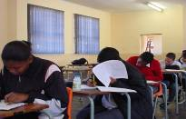
- There is confusion in the school about what community outreach means, and, as a result, the school has done little to service the broader community.

- The community, however, has a very positive view of the school as an educator of the young. Unfortunately, some parents have expressed doubts about the school spending money on ICTs, while other members of the community have actively opposed the introduction of ICTs at the school, as they fear the changes that technology may bring.
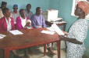
- Relationships with the Department are not very good, despite the Principal’s good standing, and there is often miscommunication. The Department has not responded to the school’s request for additional funding to install an additional security door at the school to help protect the new equipment.


- The school uses labour from the community whenever possible. Some
members of the community show their support for the school by offering their skills free of charge. For example, an SGB member who is an expert cabinet maker made additional storage cupboards for the school.

- Most guardians/parents pay a school fee of R30 per year, but that is their
only involvement. Because of socio-economic circumstances in the community, if the school were to ask parents to pay an additional ICT levy, most parents would not be able to afford this, even if it were a small amount.

- There is a local businesswoman who is supportive of the school. She often makes donations to the school in cash and kind. She has asked the school to allow her to use one of the school’s computers to capture some of her business records and transactions. For the use of the school’s computer, after school hours, she has offered to pay the school a pro-rata rate.


