

YOUR NAME:

Activity 7A - Budgeting

Steps to follow when drawing up a general school budget

General

When preparing a school budget:
- Work as a team or sub–committee.
- Consult widely about anticipated activities or events.
- Have the draft budget approved by the parent body and the SGB.

The Expenditure Budget
- Identify the areas or activities on which money needs to be spent (ie. identify categories of expenditure).

- Identify the line items for each area or activity.
- Work out how much each line item is likely to cost for the year. Do not guess. Phone suppliers or go and look in the shops, so that costs are reflected accurately.
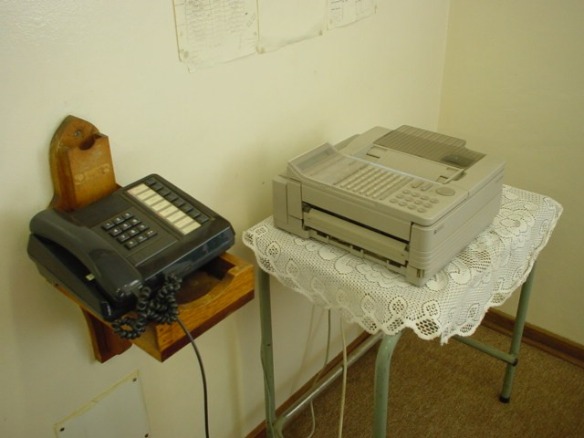
- Keep your notes (explaining how you arrived at a budget amount) in a file for future reference.
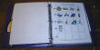
- Type up your budget, check figures, make sure you have left nothing out.
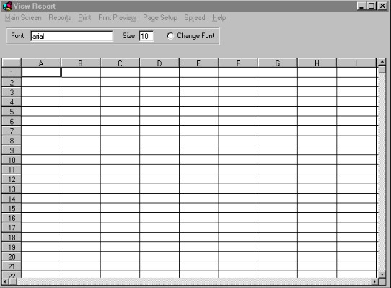
- Present the budget to the appropriate Committee (Finance Sub–Committee, SGB etc).

- Amend the budget as agreed by school stakeholders and the appropriate school committees.
- Use the budget to monitor your finances.

The Income Budget

- Work out how much money you can realistically expect to raise from school fees.
- List other ways the school already generates additional money, and how much you can realistically expect to raise from this for ICTs at the school.
- Work out your shortfall.
- Present this to the appropriate school committees, together with the Expenditure Budget.
- Develop a fundraising and income-generation plan for the school.
- Do not rely too heavily on promises of generous funding from external school partners.

Monitoring the Budget

- Annual amounts should be broken down into chunks which reflect the school’s anticipated monthly expenditure.
- Monthly expenditure can vary – think of school holidays, exam time, and so on.
- Look at the amount spent on each item every month and compare it with the budgeted amount.
- The difference between the budgeted amount and the amount spent is called a variance.
- A positive variance occurs when you have spent less than the allocated amount.
- A negative variance occurs when you have spent more than the allocated amount.
- As long as you do not have a positive variance for every item, you can still balance your accounts.
- The person controlling the budget must be able to explain under- and/or over-spending to school stakeholders.

General Budgeting Tips:

- Do not do school budgeting alone – work with someone or with an ICT budget sub-committee, for example.
- Prepare a draft budget for discussion, before it is finalised and approved - be open to making changes.
- The Principal is the Chief Executive Officer of the school and should be involved in the budgeting process and the monitoring of budgets.
- Monitor your school budget and seek to continually improve its accuracy and appropriateness for the school.
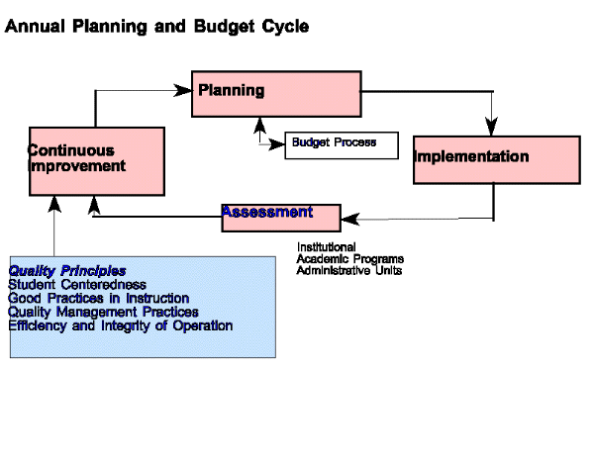
- Check your figures, as it is easy to make simple, calculation mistakes or leave important items unaccounted for.
- When you budget for the future, remember that inflation increases should be accounted for. For example, if a computer mouse or other ICT accessory costs R100 this year, it may cost R110 next year.

- Also, remember that you should not inflate the costs for budget items automatically – the Department of Education demands that school budgets are related to real needs and actual costs.
- Be just as concerned about how you are going to bring money into the school, as you are about how you are going to spend it.
- Make a plan about how you are going to encourage parents to pay school fees, so that a portion of these fees might be directed towards payments for ICT-related costs at the school.
- Encourage clubs, sports teams and cultural committees to contribute to the income of the school. For example, they might be encouraged to raise funds to pay for their own activities/functions, etc.
- Above all, do not guess line item costs in your budget. Instead, take the time to verify with suppliers the costs of items.



