Algebra | Unit 1 | Number Tricks
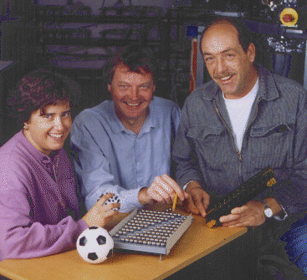
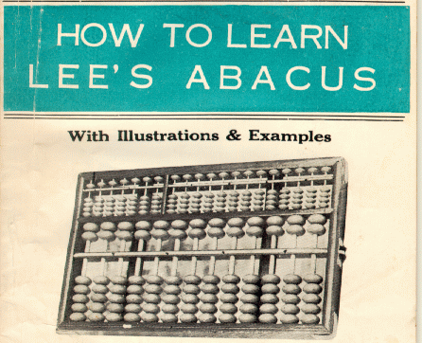
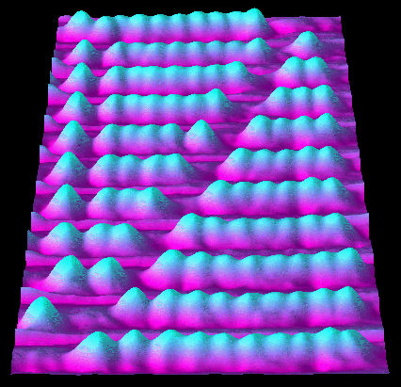

A Chinese Abacus that uses beads to represent numbers for counting and calculations.
Scientists demonstrating the smallest abacus in the world (inset) which uses tiny molecules as bead to represent the numbers 1 to 10..

WHAT THIS UNIT IS ABOUT

In this you will be learning how to solve problems using numbers. Algebra is the mathematical language we use to represent number problems. Pictures and diagrams will be used to help you to understand algebra.

You will be playing a number trick on your partner in this unit that will help you to represent numbers using algebra. You will then investigate how this trick works and how the numbers you used can be represented by an algebraic expression. You will also need to learn the words that are used to describe the different parts of an algebraic expression, words like variable, term and coefficient. Finally you will be translating word puzzles into algebraic expressions.

In this unit you will

Play a number trick on your partner that demonstrates that you can add, multiply, subtract and divide numbers accurately.

Use a flow diagram to show the calculations you used for the number trick.

Demonstrate understanding how the variable x is used in expressions to represent ‘any number’.

- Name the different parts of an algebraic expression.

- Write down algebraic expressions from word puzzles

- Use algebra to represent the cost of different fruit in Pick & Pay

Activity 1

Number Tricks

Try out the number trick below with a partner. One of you should ask the questions and the other should work out the answers. The question mark can be any number. Remember the number but don’t tell your partner.

Swap around and try it again when you have finished.

Think of any number
Add 5
Mmm!
?
Mmm!
?+5


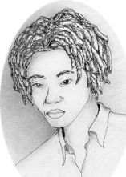
OK
Ready
Multiply the answer by 2
Mmm!
(?+5)x2
Subtract 4
Divide the answer by 2
Subtract the number you started with.
Mmm!
((?+5)x2)-4
OK

OK
Got it

Wow??

Add 1
I bet your answer is 4

Activity 2

Investigating this trick

Using Flow charts to represent step-by step calculations.

This method shows how you can solve number puzzles using a flow diagram to show how to do the calculations step-by-step.
  - Draw up some flow diagrams like the one below and fill in the answers you get after each step. Try it out for 2 or three different guesses.

-4
$+5$$2$$−?$$+1$$2$
?

Using an Algebraic expression to solve the number puzzle

The number expression can be translated into an algebraic expression by replacing the question marks with x’s.
$\begin{aligned}=\frac{\left(2x+\text{10}−4\right)}{2}−x+1 \\ =\frac{2x+6}{2}−x+1 \\ \text{etc}\end{aligned}$$\frac{\left(\left(\left(x+5\right)×2\right)−4\right)}{2}−x+1$
2.2 Reduce the expression shown and see if you can explain why your trick works. The first few steps have been done for you.


You can use algebra to make up your own number trick. Just make sure you subtract the mystery number x.

Activity 3

Naming the parts in Algebra

The following exercise will help you to name the different parts of an algebraic expression.
3.1 Rewrite the sentences below by choosing the words that make the statements true.

- 6 is called the numerical coefficient/variable of the expression 6x² because it is the number that x² must be multiplied by.
- In the expression x³, x is the base/index or exponent and 3 is the base/index or exponent.
- 2x² and 3x are called the terms/coefficient of the algebraic expression 2x² +3x. They are added together in this example but they can also be subtracted.
- 5ab and 7ab are called like terms/unlike terms. They can be combined (added in this case) to form a single term.
- 6x² , 3x and 5y are like terms/unlike terms and cannot be combined into a single term.
- In the expression 2x +3, x is called the variable/constant because it can take different values and 3 is the variable/constant because it has a fixed value.
- A binomial/polynomial/trinomial is an algebraic expression with two or more terms.
- The expression 3x – 4y + z can also be called trinomial/binomial because it consists of three terms.
- A binomial is an algebraic expression that contains one/two/three terms.
Now compare your answers with a partner. Discuss any differences and make sure you all agree about the correct words.
You will need to learn these words

Activity 4

Talking Algebra

Writing algebraic expressions from word problems is a very important skill in mathematics. The following tasks will help you to practice these skills. The following rules may also help:

- Always let the unknown ‘starting’ number in the expression be some letter, like x.
- If there are two unknown numbers, let the first unknown be one letter, like x and the second be a different letter, like y.
- Any quantity is actually a number, an age, a length, a salary, they are all just numbers.
- Look for the key words times: less than; greater than; all together or sum; divided by; etc. - to work out which operators to use.
- Remember that the multiplication sign is left out of terms. (e.g $6x=6×x$ )
- Write down the expression one step at a time.
4.1 Write algebraic expressions for the word problems listed below.

Example

Seven times a number plus three.

Let the number be x
Seven times the number = 7x
Seven times the number plus three =7x+3

Six times a number

The sum of two different numbers
- A person’s salary divided by four.
- Her sister is two times older than her.
- There are three times more people in this area than where I live
- Three less than one half the length
- The sum of three times a number and two
4.2 Now write a word phrase for each of the following algebraic expressions. In these examples the unknown numbers are not always called x

- y + y
- 13k + 7
- 2a + 5b
- 2(x + y)
- 2x + 6
- n²
- 3f – 9
In Pick’ n Pay, oranges cost R6.00 per kilogram more than bananas. Apples cost twice as much as bananas. Pears cost three times as much as oranges, and kiwi fruit cost R2.00 more than three times the cost of oranges.

4.3 Select one fruit to be the variable and write then write algebraic expression for the cost in kilograms of each fruit.

