Tipsheet on zooming into the Star Chart

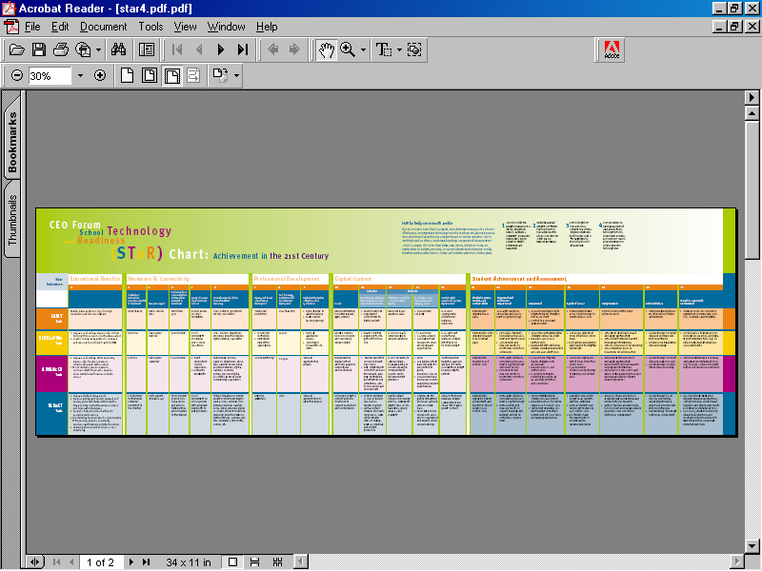

Zooming Tip:

Step 1:
To read this pdf file, you will find that it is larger than your screen. Notice that there is a magnifying glass at the top of your tool bar. This will help you to read this document.

Click on the magnifying glass at the top of the tool bar. When you click on this icon, the magnifying glass will turn to a blue colour, telling you that the command is active.

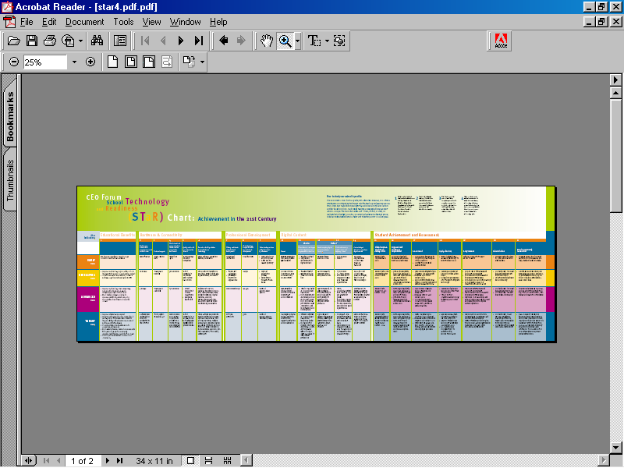
When you take your cursor down over various parts of the screen you now find that a small magnifying glass accompanies your mouse movements. When you find an area that you are interested in reading, click on that area.

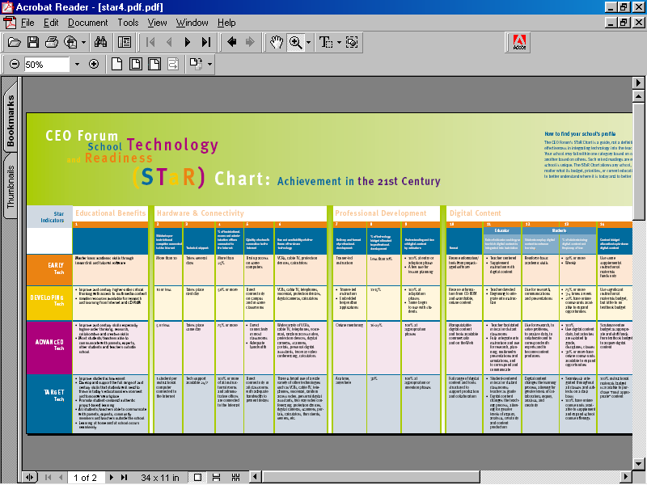

Step 2:

You may find that one click does not give you the resolution you need. In that case, click on the same area until you are able to see that section of the chart document clearly.

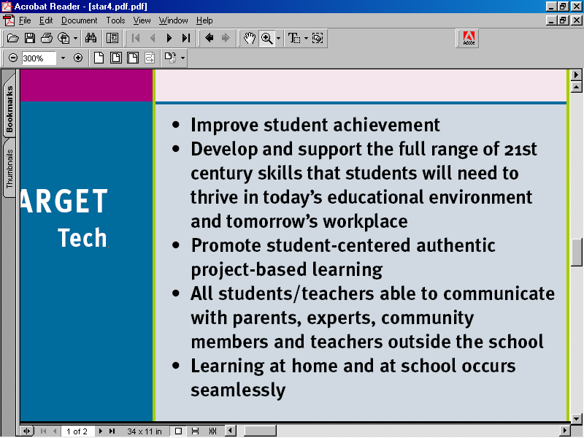

Try zooming on various aspects of this resource. You will find the exercise worthwhile, as the resource is a particularly relevant and well-thought out one.

Step 3: Write additional notes/thoughts to yourself in your portfolio.
Step 4: Further Experimentation

Instead of zooming as mentioned above, you can also click on the word `View’, which is found above other icons on the tool bar.

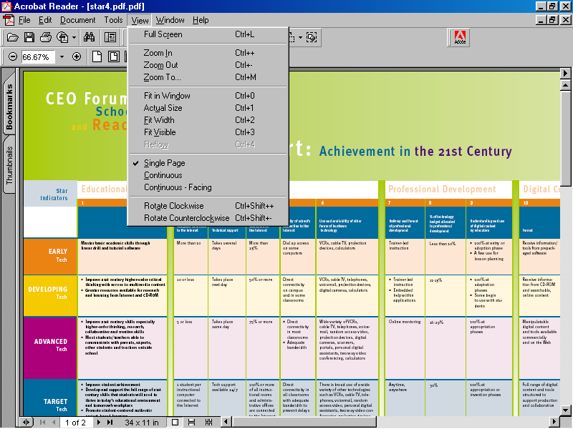

A drop down menu appears after you have clicked on the word ‘View’. In the drop down menu, select the option of: `Actual Size’. This option will allow you to read a fair portion of the chart at one time.

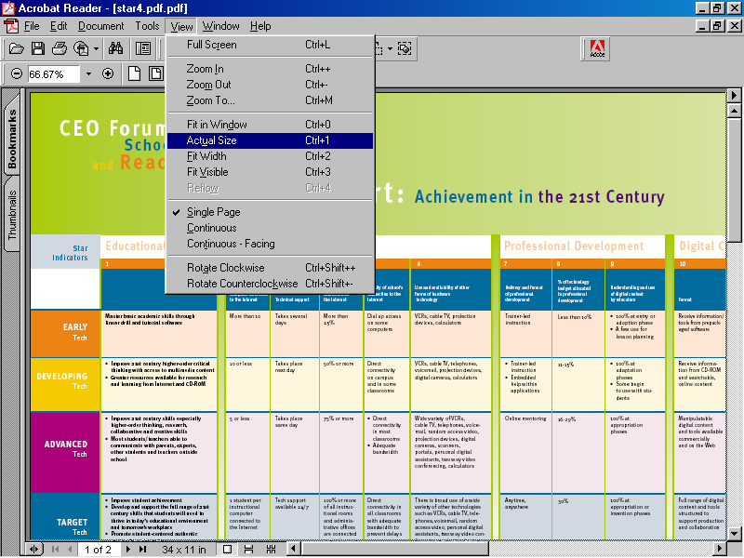

Click on this option and assess the results according to your purposes.
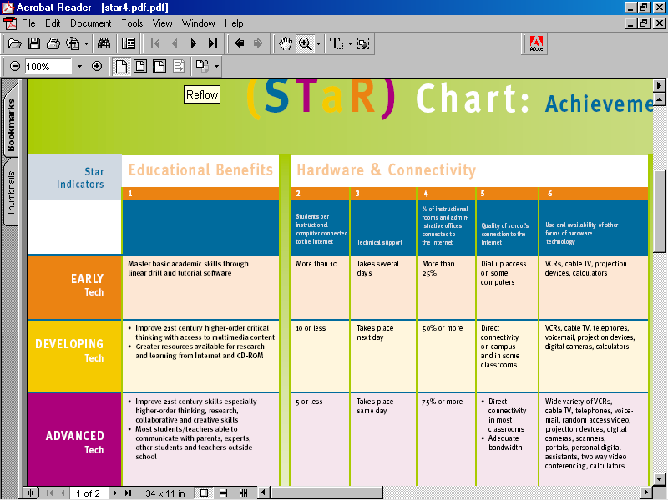

Use the option that you prefer. You may find that a combination of options suits you. When using ICTs, you will find that there is never just one way to do things. Experiment here, as elsewhere, and enjoy!

