Learner Support Material: Road to Democracy in South Africa

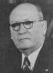
Fill in the flow chart below. Delete the question and rewrite it as an answer to create a chronological timeline of the Apartheid era (for example the first box requires you to write ‘The NP came to power in 1948’. This exercise will help you when you construct your newsletter, presentation and web site later in this unit.)

What year did the National Party come to power in South Africa?

1

2
The Population Registration Act was passed in …
The leader of the NP was ….
The racial policy they wanted to implement became known as …
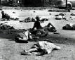
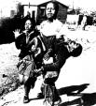
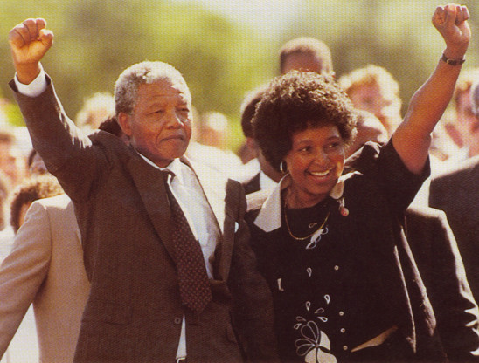
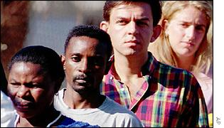

When did this man become Prime Minister? Name him.
3
The Group Areas Act was passed in …

4
3 laws passed in 1953 included:
a] ………………
b] ……………..
c] ……….…….

5
6

When was theSharpeville massacre?

7

When was the Soweto Student Riots?

9

When were the first democratically held elections in South Africa?

8

Need Help? See http://africanhistory.about.com/library/bl/blsalaws.htm
Need More Help? See this attached file http://africanhistory.about.com/library/bl/blsalaws.htm
When was Nelson Mandela Released from Victor Verster Prison?

